LIǪUID COIL AND EXTRUSION COATINGS GUIDE SPECIFICATIONS

SECTION 05 05 13
SHOP-APPLIED FLUOROPOLYMER COATINGS FOR METAL

THIS GUIDE SPECIFICATION IS WRITTEN
ACCORDING TO CSI SECTIONFORMAT®
FOR THE LATEST UPDATES,
PLEASE VISIT KYNAR500.COM
TO SPEAK WITH A KYNAR AǪUATEC® REPRESENTATIVE,
CALL 1-800-KYNAR-50

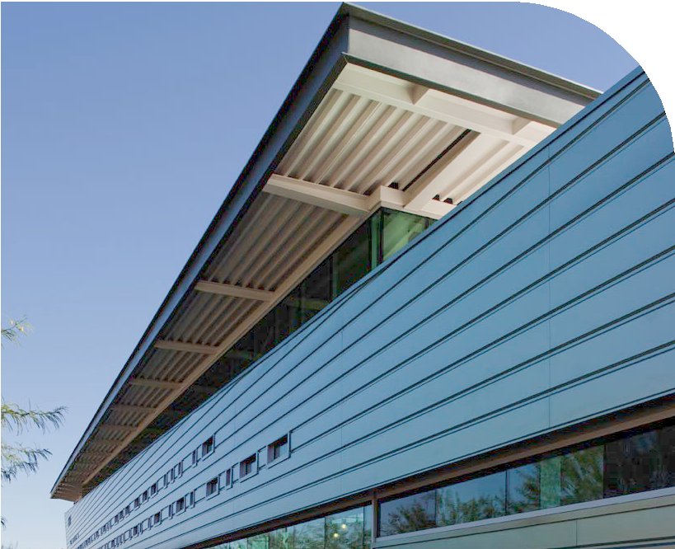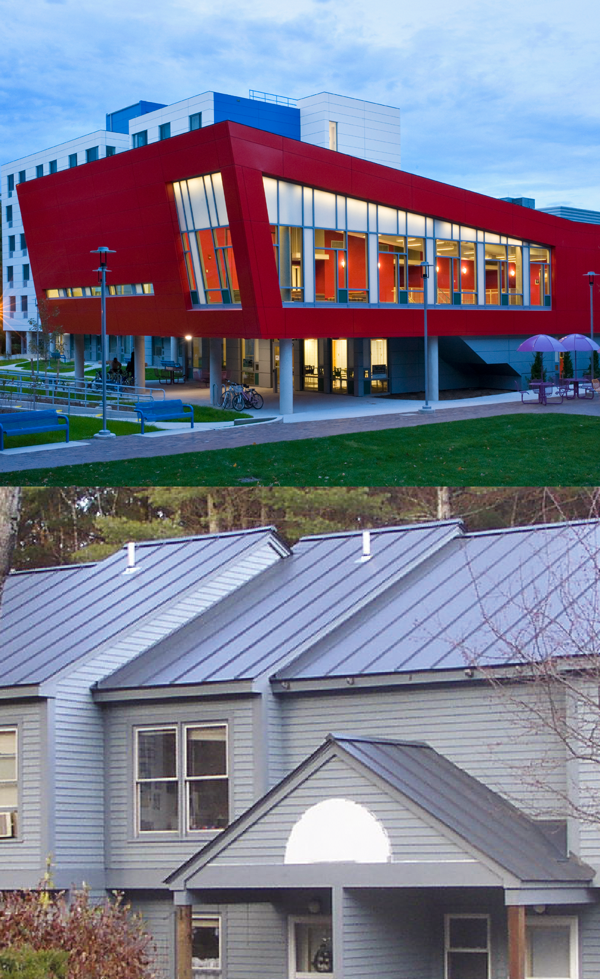WALL PANELS

ROOFING
SIDING

WINDOW PROFILES

SECTION 05 05 13

SHOP-APPLIED FLUOROPOLYMER COATINGS FOR METAL

******************************************
The paint systems specified in this section are based on the use of Kynar® or Kynar 500® FSF® PVDF resin as the basis of design.
******************************************

PART 1 GENERAL

  - SUMMARY

    - Section Includes:
******************************************
Select one or more of the following systems according to the project requirements. If selecting more than one system, clearly indicate the limits of each system and identify each system on the drawings.

70% Kynar 500® FSF® resin-based coatings comply with AAMA 2605. This AAMA Standard requires that coatings meet the 10 year Florida weathering requirements. 70% Kynar 500® FSF® resin-based coatings typically carry the longest term performance warranties.

Only a coating that contains 70% Kynar 500® FSF® resin can be branded a Kynar 500® FSF® coating.

50% Kynar® resin-based coatings comply with AAMA 2604 and AAMA 621. These AAMA Standards require that coatings meet the 5 year Florida weathering requirements.

******************************************

******************************************
The 2 systems listed below are spray coating systems that are used on cast, stamped, and extruded metal products.
******************************************

      - [Shop-applied, spray coating system, 70% [Kynar 500® FSF® resin-based], fluoropolymer coating system.]
      - [Shop-applied, spray coating system, 50% [Kynar® resin-based], fluoropolymer coatings system.]
******************************************
The 2 systems listed below are coil coating systems that are used on flat sheet metal sheet products.
******************************************

      - [Shop-applied, coil coating system, 70% [Kynar 500® FSF® resin-based], fluoropolymer coating system, on aluminum.]
      - [Shop-applied, coil coating system, 50% [Kynar® resin-based], fluoropolymer coating system on steel.]

    - Related Sections
******************************************
The list of related sections below is only an example. If including the Related Section paragraph, be sure to delete section from the list below that are not part of the project, and add sections which are part of the project but not listed. Verify section titles.
******************************************

      - Division 01 Section "Sustainable Design Requirements".
      - Division 05 Section "Pipe and Tube Railings".
      - Division 05 Section "Decorative Metal".
      - Division 05 Section "Decorative Metal Railings".
      - Division 05 Section "Decorative Formed Metal".
      - Division 07 Section "Metal Roof Panels".
      - Division 07 Section "Metal Wall Panels".
      - Division 07 Section "Sheet Metal Roofing".
      - Division 07 Section "Sheet Metal Flashing and Trim".
      - Division 07 Section "Roof Specialties".
      - Division 08 Section "Overhead Coiling Doors".
      - Division 08 Section "Overhead Coiling Grilles".
      - Division 08 Section "Aluminum-Framed Entrances and Storefronts".
      - Division 08 Section "All-Glass Entrances and Storefronts".
      - Division 08 Section "Automatic Entrances".
      - Division 08 Section "Revolving Door Entrances".
      - Division 08 Section "Glazed Aluminum Curtain Walls".
      - Division 08 Section "Structural-Sealant-Glazed Curtain Walls".
      - Division 08 Section "Aluminum Windows".
      - Division 08 Section "Metal-Framed Skylights".
      - Division 08 Section "Louvers and Vents".
      - Division 10 Section "Metal Lockers".
      - Division 13 Section "Metal Building Systems".
      - Division 08 Section "Louvers and Vents".

  - DEFINITIONS

    - FSF® resin: Arkema Inc. trademark denoting a PVDF resin made without the use of a fluorosurfactant.

    - PVDF: Polyvinylidene Fluoride.

    - LEED®: Leadership in Energy and Environmental Design (LEED®) is a sustainable (green) building rating systems developed by the U.S. Green Building Council (USGBC).

    - VOC: Volatile Organic Compounds.

  - REFERENCE STANDARDS
******************************************
This article may be deleted if this information is provided in Section 01 42 00 References. If including the Reference Standards article, edit it after editing of the remainder of this section has been completed. Only keep those items specifically referenced in other articles of this section.
******************************************

    - American Architectural Manufacturers Association (AAMA).

      - AAMA 2604 Voluntary Specification, Performance Requirements and Test Procedures for High Performing Organic Coatings on Aluminum Extrusions and Panels.
      - AAMA 2605 Voluntary Specification, Performance Requirements and Test Procedures for Superior Performing Organic Coatings on Aluminum Extrusions and Panels.
      - AAMA 621 Voluntary Specifications for High Performance Organic Coatings on Coil Coated Architectural Hot Dipped Galvanized (HDG) and Zinc-Aluminum.

    - ASTM International (ASTM)

      - ASTM B 117 – Practice for Operating Salt Spray (Fog) Apparatus.
      - ASTM B 244 – Standard Test Method for Measurement of Thickness of Anodic. Coatings on Aluminum and of Other Nonconductive Coatings on Nonmagnetic Basis Metals with Eddy-Current Instruments.
      - ASTM D 523 – Standard Test Method for Specular Gloss.
      - ASTM D 968 – Standard Test Methods for Abrasion Resistance of Organic Coatings by Falling Abrasive.
      - ASTM D 1308 – Standard Test Method for Effect of Household Chemicals on Clear and Pigmented Organic Finishes.
      - ASTM D 1400 – Standard Test Method for Nondestructive Measurement of Dry Film Thickness of Nonconductive Coatings Applied to a Nonferrous Metal Base.
      - ASTM D 1654 – Standard Test Method for Evaluation of Painted or Coated Specimens Subjected to Corrosive Environments.
      - ASTM D 2244 – Test Method for Calculation of Color Differences from Instrumentally Measured Color Coordinates.
      - ASTM D 2247 – Standard Practice for Testing Water Resistance of Coatings in 100% Relative Humidity.
      - ASTM D 2248 – Standard Practice for Detergent Resistance of Organic Finishes.
      - ASTM D 2794 – Standard Test Method for Resistance of Organic Coatings to the Effects of Rapid Deformation (Impact).
      - ASTM D 3359 – Standard Test Methods for Measuring Adhesion by Tape Test.
      - ASTM D 3363 – Standard Test Method for Film Hardness by Pencil Test.
      - ASTM D 4214 – Test Methods for Evaluating Degree of Chalking of Exterior Paint Films.
      - ASTM E 1980 – Practice for Calculating Solar Reflectance Index of Horizontal and Low-Sloped Opaque Surfaces.

  - SUBMITTALS

    - Section [01 33 00 - Submittal Procedures] <insert section number and title>: Requirements for submittals.
******************************************
Product data sheets available by a Kynar 500® FSF® trademark licensee can be accessed through the following web site:
http://www.Kynar500.com
******************************************

    - Product Data: Submit data on all finishing products and coatings.
******************************************
If colors have already been selected prior to bidding and are listed in a finish schedule by manufacturer's color designation, delete the Samples for Initial Section paragraph below.

A list of the standard colors available by Kynar 500® FSF® trademark licensee can be accessed through the following web site:
http://www.Kynar500.com

******************************************

    - Samples for Initial Selection:

      - Submit manufacturer's complete set of color samples for initial selection.
******************************************
Retain the "for Verification" option below only if you retain the Samples for Initial Selection paragraph above.
******************************************

    - Samples[ for Verification]:

      - Submit [two] [ ] <Insert .....item >, [[6 by 6 inches] [(150 by 150 mm)]]
[[ x ] inches ([ x ] mm)] in size illustrating color, gloss, and texture for each color selected and each material to be coated.
******************************************
Modify the Certificates submission requirements below as needed for a non-proprietary, publicly bid project.

Kynar 500® FSF◌ׂ® resin is a high molecular weight homopolymer of vinylidene fluoride. Finishes based on Kynar 500® FSF® resin are formulated by Kynar 500® FSF® trademark licensees and contain, in addition to Kynar 500® FSF® resin, solvents and high quality pigments. According to the licensing agreement, a minimum of 70% by weight of Kynar 500® FSF® resin is required. These high quality coating systems have a proven history when exposed to severe ultraviolet radiation for extended periods (over 25 years) of time. To insure the formulation being supplied contains Kynar 500® FSF® resin manufactured by Arkema Inc. and that the coating is manufactured free of fluorosurfactants, validation from the licensee is recommended.
******************************************

    - Certificates: Certify formulations being provided [are manufactured with Arkema PVDF resin,] [contain Kynar 500® FSF® resin,] [contain Kynar® resin,] [are free of fluorosurfactants][,] and meet or exceed specified requirements of this section.

    - Test and Evaluation Reports: Submit reports indicating conformance with physical properties specified and requirements of AAMA 2605.
******************************************
Retain one of the 3 Qualification Statement options and delete the other. Keep the 3rd option for a non- proprietary, publicly bid project.

Kynar 500® FSF◌ׂ® resin is a high molecular weight homopolymer of vinylidene fluoride. Finishes based on Kynar 500® FSF® resin are formulated by Kynar 500® FSF® trademark licensees and contain, in addition to Kynar 500® FSF® resin, solvents and high quality pigments. According to the licensing agreement, a minimum of 70% by weight of Kynar 500® FSF® resin is required. These high quality coating systems have a proven history when exposed to severe ultraviolet radiation for extended periods (over 25 years) of time. To insure the formulation being supplied contains Kynar 500® FSF® resin manufactured by Arkema Inc. and that the coating is manufactured free of fluorosurfactants, validation from the licensee is recommended.
******************************************

    - Qualification Statements: Submit documentation indicating that coating manufacturer is a [Kynar® licensee] [Kynar 500® FSF® licensee] [licensee of the resin manufacturer].

  - SUSTAINABLE DESIGN SUBMITTALS

    - Section [01 81 13 - Sustainable Design Requirements] <insert section number and title>: Requirements for sustainable design submittals.

    - Manufacturer's Certificate: Certify products meet or exceed specified sustainable design requirements below.

      - Indoor Air Quality Certificates:
******************************************
Currently, LEED® criteria do not call for VOC limits on coating systems applied in a shop or factory. LEED® criteria also do not currently call for VOC limits on coating systems that are applied on site to surfaces that are outside the weatherproofing system. However, by voluntarily exceeding LEED® VOC criteria, a project may qualify for a LEED® Innovation in Design (ID) Credit. Consult with the project's LEED® Accredited Professional to verify before editing.
******************************************

        - Certify volatile organic compound content for each interior paint and coating.

  - QUALIFICATIONS

******************************************
Retain one of the 3 Manufacturer Qualification options and delete the other. Keep the 3rd option for a non-proprietary, publicly bid project.

A current list of Kynar 500® FSF® licensees can be viewed at www.kynar500.com.
******************************************

    - Manufacturer: Company specializing in the manufacture of coatings specified in this section that is a [Kynar® licensee] [Kynar 500® FSF® licensee] [licensee of the resin manufacturer].

******************************************
Edit Part 2 Products before editing the Applicator Qualification requirements below.
******************************************

    - Applicator: Company specializing in the applications of coatings specified in this section in adherence to [AAMA 2604] [AAMA2605] [AAMA 621] and is approved by the coating manufacturer.

  - MOCKUP

    - Section [01 40 00 - Quality Requirements] <insert section number and title>: Requirements for mockup.

    - Apply coating system to mockups of assemblies specified in other Sections to receive coating system as a finish. Apply coating systems to mockups in compliance with the requirements of this Section.

  - WARRANTY

    - Section [01 70 00 - Execution and Closeout Requirements] <insert section number and title>: Requirements for warranties.

    - Coating Applicator’s Warranty: Applicator agrees to repair finish or replace coated items that demonstrate deterioration of [shop-applied, spray coating system] [shop-applied, coil coating system] finished within warranty period indicated.

      - Exposed Coating: Deterioration includes but is not limited to:

        - Color fading in excess of 5 Delta E Hunter units per ASTM D 2244.
        - Peeling, checking, or cracking of coating adhesion to metal.
        - Chalking in excess of a No. 8 when tested per Method D 4214.
        - Corrosion of substrate in excess of a No. 6 on cut edges and a No. 9 on field surfaces, when measured per ASTM D1654.

******************************************
Verify the availability of warranty period available before selecting the number of years.
******************************************

      - Warranty Period: [10] [20] [25] [30] years from date of Substantial Completion.

PART 2 PRODUCTS
******************************************
If specifying only one type of coating system, delete the MANUFACTURERS Article below.

If specifying more than one type of coating system, keep the MANUFACTURERS Article below and delete Manufacturers paragraphs in the Articles for each coating system to be used.
******************************************

  - MANUFACTURES

    - Manufacturer, Resin: Subject to compliance with requirements, provide coating systems containing [Kynar®] [Kynar 500® FSF®] PVDF resin by:

      - Arkema Inc.

    - Manufacturer, Coating System
******************************************
Refer to Arkema's Kynar 500® web site for current list of manufacturers licensed to provide coating systems containing Kynar 500® FSF® resin by Arkema. www.kynar500.com
******************************************

      - <Insert name of Kynar 500® FSF® licensee>
      - <Insert name of Kynar 500® FSF® licensee>
      - <Insert name of Kynar 500® FSF® licensee>
      - Substitutions: [Section 01 60 00 - Product Requirements] [Section <insert section number and title>] [Not Permitted].

******************************************
Select one or more of the following systems in the next 4 articles according to the project requirements. If selecting more than one system, clearly indicate the limits of each system and identify each system on the drawings.
******************************************

  - Superior Performance Organic Coating on Aluminum Extrusions

    - Liquid Fluoropolymer Aluminum Extrusion Coatings, AAMA 2605: Minimum 70 percent Kynar 500® FSF® PVDF resin, by weight, in color coat [and clear coat]
******************************************
See www.kynar500.com for an up to date list of coatings containing Kynar 500® FSF® resin.
******************************************

      - Product : <insert product name>
      - Pencil Hardness, ASTM D3363: F minimum.
      - Dry Film Thickness, ASTM D1400: 0.20 mil primer coat plus 1.0 mil color coat, 1.20 mil total, minimum thickness.
      - Dry Film Thickness, ASTM D1400: 0.20 mil primer coat plus [1 mil barrier coat,] 1.0 mil color coat and 0.4 mil clear topcoat, [1.6 mil] [2.6 mil] total, minimum thickness.

***** [OR] ******

  - High Performance Organic Coating on Aluminum Extrusions

    - High Performance Liquid Fluoropolymer Aluminum Extrusion Coatings, AAMA 2604: Minimum 50 percent Kynar® PVDF resin, by weight, in color coat.
******************************************
See www.kynar500.com for an up to date list of 50% coatings containing Kynar® resin.
******************************************

      - Product : <insert product name>
      - Pencil Hardness, ASTM D3363: F minimum.
      - Dry Film Thickness, ASTM D1400: 0.20 mil primer coat plus 1.0 mil color coat, 1.20 mil total, minimum thickness.

***** [OR] ******

  - Superior Performance Organic Coatings on Aluminum Panels

    - Superior Performance Liquid Fluoropolymer Coil Coatings, AAMA 2605: Minimum 70 percent Kynar 500® FSF® PVDF resin, by weight, in color coat.
******************************************
See www.kynar500.com for an up to date list of coatings containing Kynar 500® FSF® resin.
******************************************

      - Product : <insert product name>
      - Pencil Hardness, ASTM D3363: F minimum.
      - Dry Film Thickness, ASTM D1400: 0.20 mil primer coat plus 1.0 mil color coat, 1.20 mil total, minimum thickness.
      - Dry Film Thickness, ASTM D1400: 0.20 mil primer coat plus [1 mil barrier coat,] 1.0 mil color coat and 0.4 mil clear topcoat, [1.6 mil] [2.6 mil] total, minimum thickness.

***** [OR] ******

  - High Performance Organic Coatings on Coil Coated Architectural Hot Dipped Galvanized (HDG) and Zinc-Aluminum Coated Steel Substrates

    - High Performance Liquid Fluoropolymer Coil Coatings, AAMA 621: Minimum 50 percent Kynar® PVDF resin, by weight, in color coat.

******************************************
See www.kynar500.com for an up to date list of 50% coatings containing Kynar® resin.
******************************************

      - Product : <insert product name>
      - Pencil Hardness, ASTM D3363: HB minimum.
      - Dry Film Thickness, ASTM D1400: 0.20 mil primer coat plus 0.70 mil color coat, 0.90 mil total, minimum thickness.

  - PRIMER MATERIALS

    - Manufacturer's standard for finish and substrate indicated.

  - SHOP FINISHING METHODS

    - Mechanically clean and chemically pretreat fabricated items in accordance with the coating manufacturer’s requirements and AAMA requirements for the finish indicated.

    - Apply primer and finish coats in accordance with the coating manufacturer’s requirements for the finish indicated.

  - SOURCE QUALITY CONTROL AND TESTS

    - Section [01 40 00 - Quality Requirements] <insert section number and title>: Testing, inspection and analysis requirements.

    - Test coatings in accordance with requirements of AAMA 2605 to verify compliance with the following:

Property | ASTM Test Method | Performance
Color Uniformity |  | Meets or Exceeds Specification
Specular Gloss | D 523 | Medium Gloss
Dry Film Hardness | D 3363 | Meets or Exceeds Specification
Dry Film Adhesion | D 3359 | No Adhesion Loss
Wet Film Adhesion | D 3359 | No Adhesion Loss
Boiling Water Adhesion | D 3359 | No Adhesion Loss
Impact Resistance | D 2794 | No Cracking or Adhesion Loss
Abrasion Resistance | D 968 | Meets or Exceeds Specification
Muriatic Acid Resistance | D 1308 | No Effect
Mortar Resistance |  | No Effect
Nitric Acid Resistance |  | Meets or Exceeds Specification
Detergent Resistance | D 2248 | No Effect
Humidity Resistance | D 2247  B 117 | Meets or Exceeds Specification
Salt Spray Resistance | D 1654 | Meets or Exceeds Specification
South Florida Weathering Exposure |  | Meets or Exceeds Specification

Color Retention | D 2244 | Meets or Exceeds Specification
Chalk Resistance | D 4214 | Meets or Exceeds Specification
Gloss Retention | D 523 | Meets or Exceeds Specification
Erosion Resistance | B 244 | Meets or Exceeds Specification

    - Make completed <Insert name of product to be coated> available for inspection at manufacturer’s factory prior to packaging for shipment. Notify Owner at least seven days before inspection is allowed.

    - Allow witnessing of factory inspections and test at manufacturer’s test facility. Notify Owner at least seven days before inspections and tests are scheduled.

PART 3 EXECUTION [Not Used]

******************************************
Refer to individual specification sections for installation requirements for items receiving shop-applied coatings.
******************************************

END OF SECTION

ADV 202205-90 - Design: JG, Images: Arkema, Getty

Arkema Inc. 900 1st Ave, King of Prussia, PA 19406
+1 610-205-7000

Headquarters: Arkema France 420 rue d’Estienne d’Orves 92705 Colombes Cedex
France
T +33 (0)1 49 00 80 80

Kynar® is a registered trademark of Arkema
©2023 Arkema Inc. All rights reserved.

Please, consult Arkema’s disclaimer regarding the use of Arkema’s products on https://www.arkema.com/global/en/products/product-safety/disclaimer/
Arkema France, a French sociéĒé anonyme registered at the Trade and Companies Register of Nanterre under the number 319 632 790
hpp.arkema.com

